Low Level Design

Criminal Analysis

|  |  |
| --- | --- |
| Written By | Sumit Kumar |
| Document Version | 0.1 |
| Last Revised Date | 26– May -2022 |

**Document Control**

### Change Record:

|  |  |  |  |
| --- | --- | --- | --- |
| **Version** | **Date** | **Author** | **Comments** |
| 0.1 | 19 – May -  2021 | Ankur Das | Introduction & Architecture defined |
|  |  | Rahul Pidkalwar | Architecture & Architecture Description appended and updated |
|  |  |  |  |
|  |  |  |  |
|  |  |  |  |
|  |  |  |  |

### Reviews:

|  |  |  |  |
| --- | --- | --- | --- |
| **Version** | **Date** | **Reviewer** | **Comments** |
| 0.2 | 21 – May -  2021 | Khusali | Document Content , Version Control and Unit Test Cases to be added |

### Approval Status:

|  |  |  |  |  |
| --- | --- | --- | --- | --- |
| **Version** | **Review**  **Date** | **Reviewed By** | **Approved By** | **Comments** |
|  |  |  |  |  |

Contents

1. Introduction 1
   1. What is Low-Level design document? 1
   2. Scope 1
2. Architecture 2
3. Architecture Description 3
   1. Data Description 3
   2. Web Scrapping 3
   3. Data Transformation 3
   4. Data Insertion into Database 3
   5. Export Data from Database 3
   6. Data Pre-processing 3
   7. Data Clustering 3
   8. Model Building 4
   9. Data from User 4
   10. Data Validation 4
   11. User Data Inserting into Database 4
   12. Data Clustering 4
   13. Model Call for Specific Cluster 4
   14. Recipe Recommendation & Saving Output in Database 4
   15. Deployment 4
4. Unit Test Cases 5

# Introduction

## What is Low-Level design document?

The goal of LLD or a low-level design document (LLDD) is to give the internal logical design of the actual program code for Criminal Analysis. LLD describes the class diagrams with the methods and relations between classes and program specs. It describes the modules so that the programmer can directly code the program from the document.

## Scope

Low-level design (LLD) is a component-level design process that follows a step-by-

step [refinement](https://en.wikipedia.org/wiki/Refinement_(computing)) process. This process can be used for designing data structures, required software architecture, source code and ultimately, performance algorithms. Overall, the data organization may be defined during requirement analysis and then refined during data design work

# Architecture

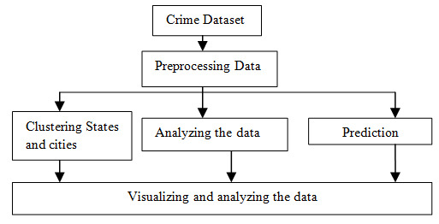

# Architecture Description

## Data Description

Baton Rouge datasetis used for the making report of criminal analysis. The information each recipe contains comma separated (csv)files. This dataset contains recipes including 490579 different ingredients.

## Web Scrapping

In order to create a more complete recipe collection we will need some more datasets which will contain Nutritional value of recipes along with Ratings and total Calories.

## Data Transformation

In the Transformation Process, we will convert our original dataset which is in JSON format to CSV Format. And will merge it with the Scrapped dataset.

## Data Insertion into Database

1. Database Creation and connection - Create a database with name passed. If the database is already created, open the connection to the database.
2. Table creation in the database.
3. Insertion of files in the table

## Export Data from Database

Data Export from Database - The data in a stored database is exported as a CSV file to be used for Data Pre-processing and Model Training.

## Data Pre-processing

Data Pre-processing steps we could use are Null value handling, stop words removal, punctuation removal, Tokenization, Lemmatization, TFIDF, Imbalanced data set handling, Handling columns with standard deviation zero or below a threshold, etc.

## 3.7User Data Inserting into Database

Collecting the data from the police criminal database and storing it into the database. The database can be either MySQL or Mongo DB.

## Data Clustering

The model created during training will be loaded, and clusters for the user data will be predicted.

## Model Call for Specific Cluster

Based on the cluster number, the respective model will be loaded and will be used to predict/Recommend the data for that cluster.

## Recipe Recommendation & Saving Output in Database

After calling model Recipe/Output will be recommended, this output will be saved in Tableau and it will be used to show the same Output if other users provide the same data.

## Dashboard/Report

## 

## The dashboard was created using Tableau software in which various charts were prepared to showcase the number of crime occurred and various others were compared .For pi chart number of crime and number is represented.Similarly crime count per year and whether crime was attempted and committed or it was just attempted but couldn’t be committed .

## Similarly various crimes and its number is represented in bar chart.